Electromagnetic Coil Gun

Wars and proxy wars were are and will keep on being razed across the world. However the most common weapon being used in conflicts are guns. All types of bullets used in guns make use of gunpowder which is used to propel the bullet, but gunpowder based blast propulsion has a lot of disadvantages.
- Gunpowder consists of toxic components that are bad for health.
- Gunpowder smoke is also toxic and also helps create harmful smog.
- Gunpowder based propulsion is a very noisy process.
- This propulsion recoil also gives a heavy kickback making targeting difficult.

Well if we cannot stop wars, the least we can do is to make them noise and pollution free. Here we propose a electromagnetic coil based gun that is capable of propelling bullets without any gunpowder.
The coil based gun provides following advantages:
- No Air Pollution
- No Noise on firing
- Very Less Recoil
- Low Production cost of Bullets

The electromagnetic coil gun makes use of a modern propulsion system that makes use of electromagnetic coils synchronized to launch a projectile at very high speeds. We make use of copper coils, electronic circuitry, capacitors, high strength metal framing to achieve this mechanism.
The coiling plays a very important role in the gun propulsion. We here use a 3 stage coil mechanism to create this gun. This includes 3 coils mounted on a single pipe. The coiling wire guage, turns and length calculations are tweaked a lot to ensure the maximum strength at desired voltage and current strength needed for desired propulsion.
The propulsion coils need to be charged and discharged in a fraction of a second in order to achieve the desired propulsion and not pull back the bullet. For this purpose we use high voltage capacitors to discharge high voltage and current in the least time to power and discharge the coil in an instant.
The bullet is just a piece of mild steel with no butt that is propelled using electromagnetic strength. An lcd display and knob is used to adjust the system parameters in order to achieve desired propulsion.
Thus the electromagnetic coil gun showcases a new propulsion mechanism for gunpowder less guns.

Components:
- Copper Coil
- Winding Core
- MS/Iron Bullet
- High Voltage Capacitors
- Trigger
- Gun Handle
- LCD Display
- Voltage Multiplier
- Battery
- Adjustment Knob
- Safety Switch
- Mounts & joints
- Screws & joints
- Resistors Capacitors
- Diodes Transistors
- PCB Board

Applications:
- Assault Rifles
- Sniper Rifles
- Artillery Systems
- Battle Tanks
- Anti Aircraft Guns
- Battleships

Advantages:
- No Air Pollution
- No Noise on firing
- Very Less Recoil
- Low Production cost of Bullets

Disadvantages:
- Gunpowder consists of toxic components that are bad for health.
- Gunpowder smoke is also toxic and also helps create harmful smog.
- Gunpowder based propulsion is a very noisy process.
- This propulsion recoil also gives a heavy kickback making targeting difficult.

Side View (Internal)

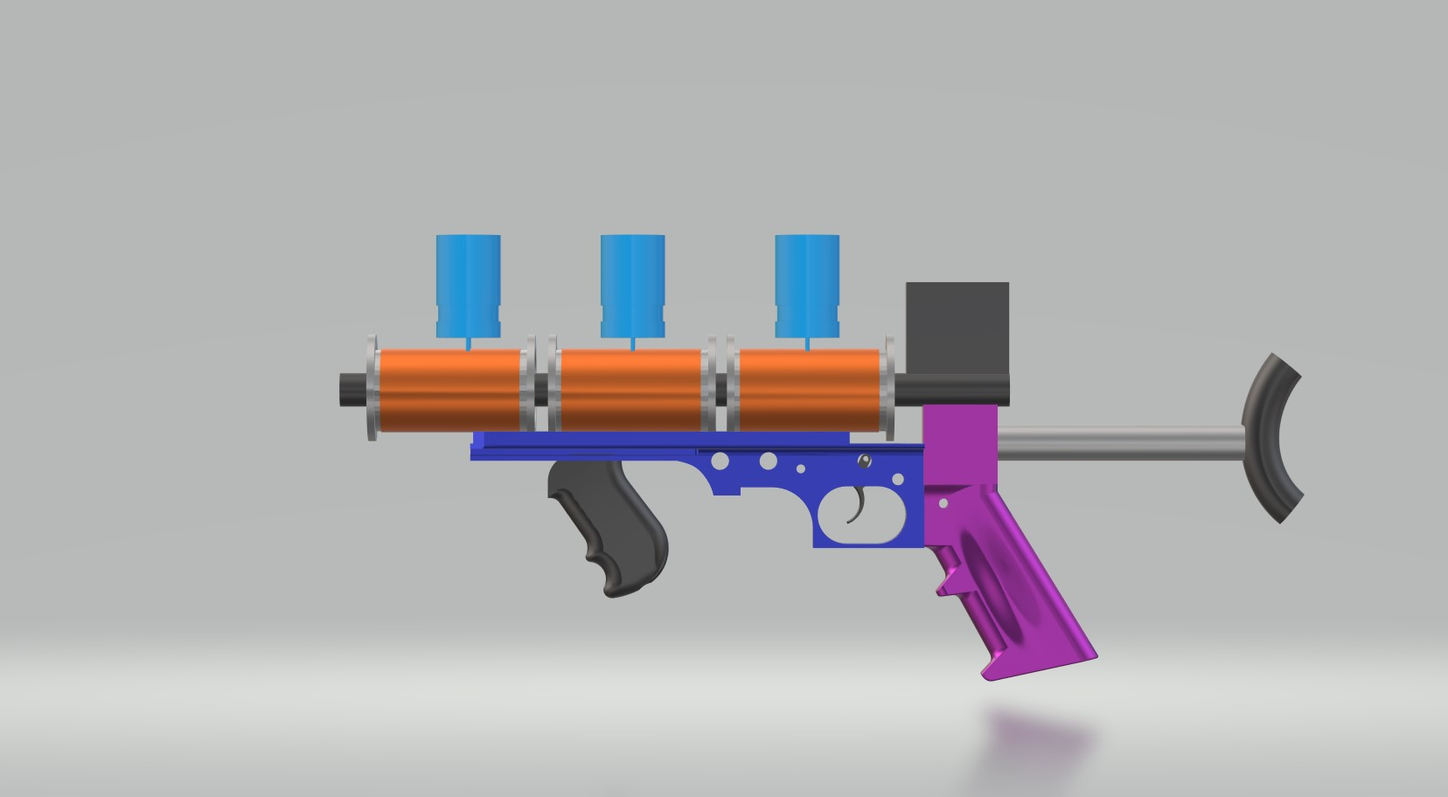

Side View (External)

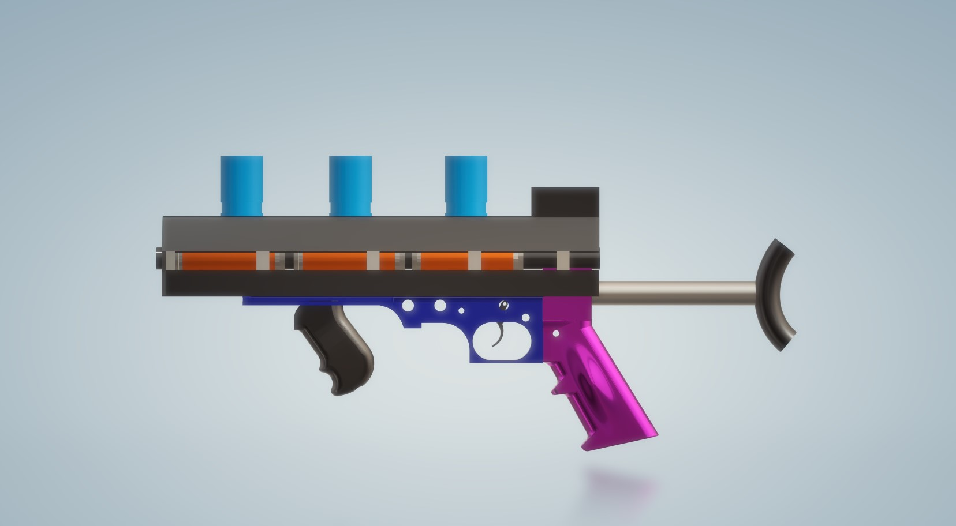

Front View (Internal)

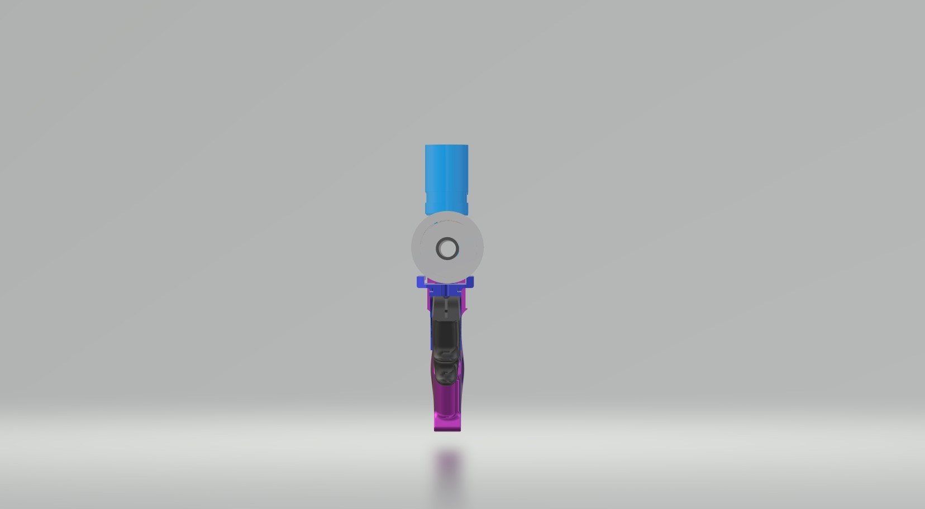

Front View (External)

